Date : 19/06/2026
Topic : Interfaces in CSS.
1.Facebook Interface (Assignment)
Code:
<!DOCTYPE html>
<html lang="en">
<head>
<meta charset="UTF-8">
<meta name="viewport" content="width=device-width, initial-scale=1.0">
<title>Facebook Login Clone</title>
<style>
*{
margin:0;
padding:0;
box-sizing:border-box;
font-family:Helvetica, Arial, sans-serif;
}
body{
background:#f0f2f5;
display:flex;
justify-content:center;
align-items:center;
min-height:100vh;
}
.container{
width:1000px;
display:flex;
justify-content:space-between;
align-items:center;
}
.left{
width:500px;
}
.left h1{
color:#1877f2;
font-size:70px;
font-weight:bold;
margin-bottom:15px;
}
.left p{
font-size:30px;
color:#1c1e21;
line-height:1.2;
}
.right{
width:400px;
}
.login-box{
background:#fff;
padding:20px;
border-radius:10px;
box-shadow:0 2px 10px rgba(0,0,0,0.2);
}
.login-box input{
width:100%;
padding:15px;
margin-bottom:12px;
border:1px solid #dddfe2;
border-radius:6px;
font-size:17px;
outline:none;
}
.login-box input:focus{
border-color:#1877f2;
box-shadow:0 0 5px rgba(24,119,242,0.3);
}
.login-btn{
width:100%;
background:#1877f2;
color:white;
border:none;
border-radius:6px;
padding:14px;
font-size:20px;
font-weight:bold;
cursor:pointer;
}
.login-btn:hover{
background:#166fe5;
}
.forgot{
display:block;
text-align:center;
color:#1877f2;
text-decoration:none;
margin:16px 0;
font-size:14px;
}
.forgot:hover{
text-decoration:underline;
}
.line{
border-top:1px solid #dadde1;
margin:20px 0;
}
.create-btn{
display:block;
margin:auto;
background:#42b72a;
color:white;
border:none;
border-radius:6px;
padding:14px 20px;
font-size:17px;
font-weight:bold;
cursor:pointer;
}
.create-btn:hover{
background:#36a420;
}
.create-page{
text-align:center;
margin-top:25px;
font-size:14px;
}
.create-page a{
color:black;
font-weight:bold;
text-decoration:none;
}
.create-page a:hover{
text-decoration:underline;
}
@media(max-width:900px){
.container{
flex-direction:column;
text-align:center;
width:90%;
}
.left{
width:100%;
margin-bottom:40px;
}
.left h1{
font-size:60px;
}
.left p{
font-size:24px;
}
.right{
width:100%;
max-width:400px;
}
}
</style>
</head>
<body>
<div class="container">
<div class="left">
<h1>facebook</h1>
<p>
Connect with friends and the world around you on Facebook.
</p>
</div>
<div class="right">
<div class="login-box">
<input type="text" placeholder="Email address or phone number">
<input type="password" placeholder="Password">
<button class="login-btn">Log In</button>
<a href="#" class="forgot">Forgotten password?</a>
<div class="line"></div>
<button class="create-btn">Create new account</button>
</div>
<div class="create-page">
<a href="#">Create a Page</a> for a celebrity, brand or business.
</div>
</div>
</div>
</body>
</html>
Output:
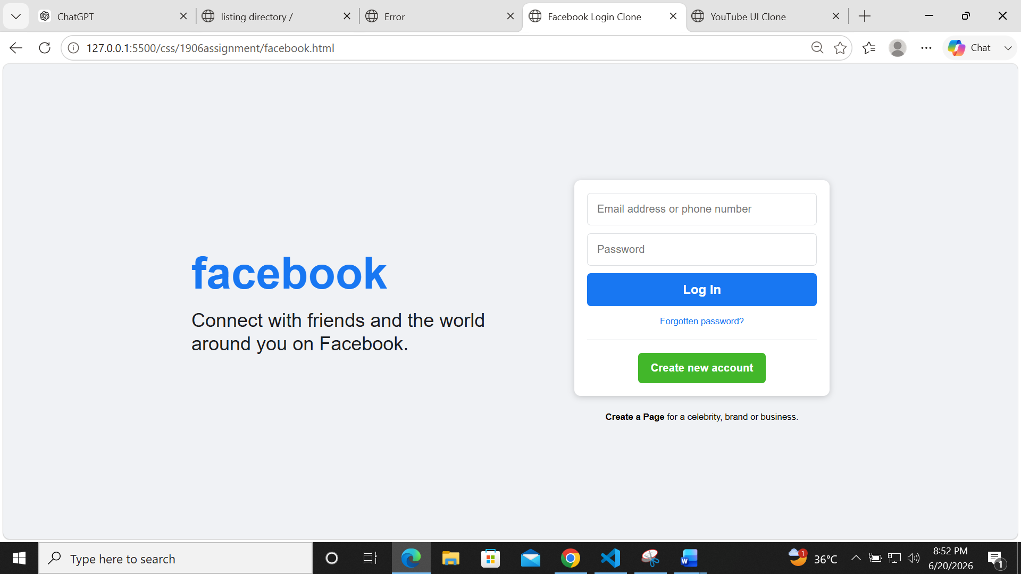

1.Youtube Interface (Assignment)
Code:
<!DOCTYPE html>
<html lang="en">
<head>
<meta charset="UTF-8">
<meta name="viewport" content="width=device-width, initial-scale=1.0">
<title>YouTube UI Clone</title>
<style>
*{
margin:0;
padding:0;
box-sizing:border-box;
font-family:Arial, Helvetica, sans-serif;
}
body{
background:#0f0f0f;
color:white;
}
/* TOP NAVBAR */
.navbar{
position:fixed;
top:0;
left:0;
width:100%;
height:70px;
background:#0f0f0f;
border-bottom:1px solid #272727;
display:flex;
align-items:center;
justify-content:space-between;
padding:0 25px;
z-index:100;
}
.logo{
display:flex;
align-items:center;
gap:8px;
font-size:20px;
font-weight:bold;
color:white;
}
.logo span{
color:red;
}
.search{
width:40%;
}
.search input{
width:100%;
height:40px;
border-radius:25px;
border:1px solid #303030;
background:#121212;
color:white;
padding:0 20px;
font-size:16px;
outline:none;
}
.profile{
width:36px;
height:36px;
border-radius:50%;
background:#8b5cf6;
}
/* SIDEBAR */
.sidebar{
position:fixed;
top:70px;
left:0;
width:100px;
height:100vh;
border-right:1px solid #272727;
padding-top:15px;
}
.side-item{
width:50px;
height:35px;
background:#272727;
border-radius:8px;
margin:15px auto;
}
.side-item:first-child{
background:#f5f5f5;
}
/* CONTENT */
.content{
margin-left:100px;
margin-top:70px;
padding:20px 25px;
}
/* CATEGORY BUTTONS */
.categories{
display:flex;
gap:12px;
margin-bottom:25px;
}
.category{
background:#272727;
border:none;
color:white;
padding:10px 18px;
border-radius:12px;
cursor:pointer;
font-size:16px;
}
.category.active{
background:white;
color:black;
}
/* VIDEO GRID */
.video-grid{
display:grid;
grid-template-columns:repeat(auto-fit,minmax(300px,1fr));
gap:20px;
}
/* CARD */
.card{
cursor:pointer;
}
.thumbnail{
width:100%;
height:180px;
border-radius:12px;
}
.blue{
background:#4285f4;
}
.green{
background:#1abc84;
}
.pink{
background:#e84393;
}
.info{
display:flex;
margin-top:12px;
}
.channel{
width:36px;
height:36px;
border-radius:50%;
margin-right:10px;
}
.red{
background:#ff4444;
}
.yellow{
background:#f4b400;
}
.blue-circle{
background:#4285f4;
}
.details h3{
font-size:22px;
margin-bottom:5px;
}
.details p{
color:#aaaaaa;
font-size:16px;
line-height:1.4;
}
/* HOVER */
.card:hover .thumbnail{
transform:scale(1.02);
transition:0.3s;
}
/* MOBILE */
@media(max-width:768px){
.sidebar{
display:none;
}
.content{
margin-left:0;
}
.search{
width:55%;
}
.video-grid{
grid-template-columns:1fr;
}
}
</style>
</head>
<body>
<!-- NAVBAR -->
<div class="navbar">
<div class="logo">
▶ <span>YouTube</span>
</div>
<div class="search">
<input type="text" placeholder="Search">
</div>
<div class="profile"></div>
</div>
<!-- SIDEBAR -->
<div class="sidebar">
<div class="side-item"></div>
<div class="side-item"></div>
<div class="side-item"></div>
</div>
<!-- MAIN CONTENT -->
<div class="content">
<div class="categories">
<button class="category active">All</button>
<button class="category">Gaming</button>
<button class="category">Music</button>
<button class="category">Live</button>
</div>
<div class="video-grid">
<!-- VIDEO 1 -->
<div class="card">
<div class="thumbnail blue"></div>
<div class="info">
<div class="channel red"></div>
<div class="details">
<h3>Learn HTML & CSS</h3>
<p>Tech Channel</p>
<p>120K views • 2 days ago</p>
</div>
</div>
</div>
<!-- VIDEO 2 -->
<div class="card">
<div class="thumbnail green"></div>
<div class="info">
<div class="channel yellow"></div>
<div class="details">
<h3>Building a Travel App</h3>
<p>Code Master</p>
<p>45K views • 5 hours ago</p>
</div>
</div>
</div>
<!-- VIDEO 3 -->
<div class="card">
<div class="thumbnail pink"></div>
<div class="info">
<div class="channel blue-circle"></div>
<div class="details">
<h3>Lofi Hip Hop Radio</h3>
<p>Chill Vibes</p>
<p>14K watching</p>
</div>
</div>
</div>
</div>
</div>
</body>
</html>
Output:
